BranchWise
What the application does
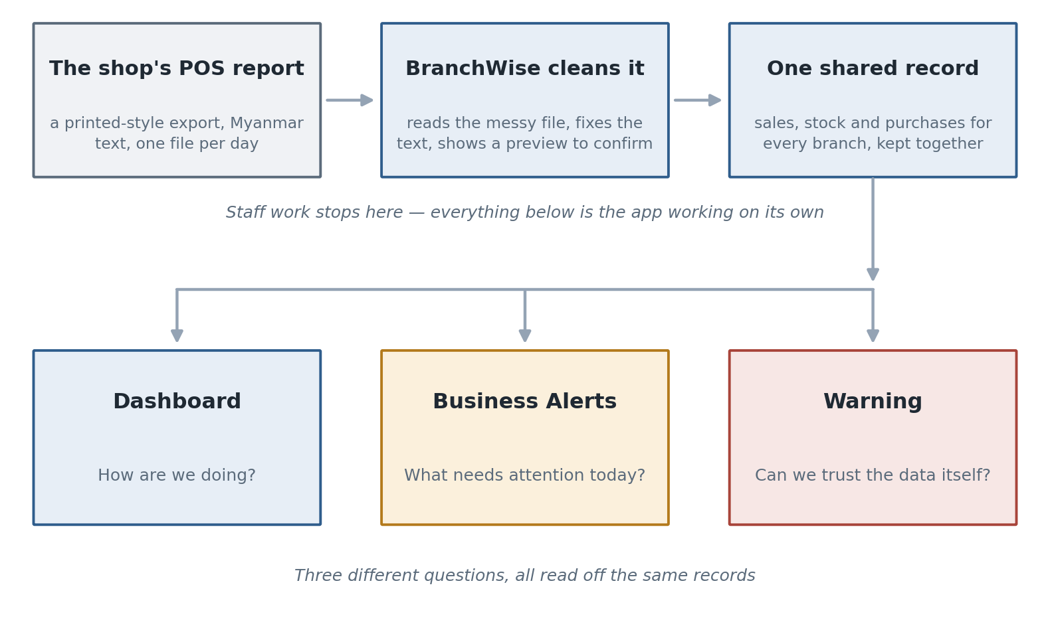
- Staff work: upload, check, confirm. About a minute a day.
- Everything after that is automatic — nobody presses anything.
- Three pages, three different questions from the same records.

Branch health: five scores, not one
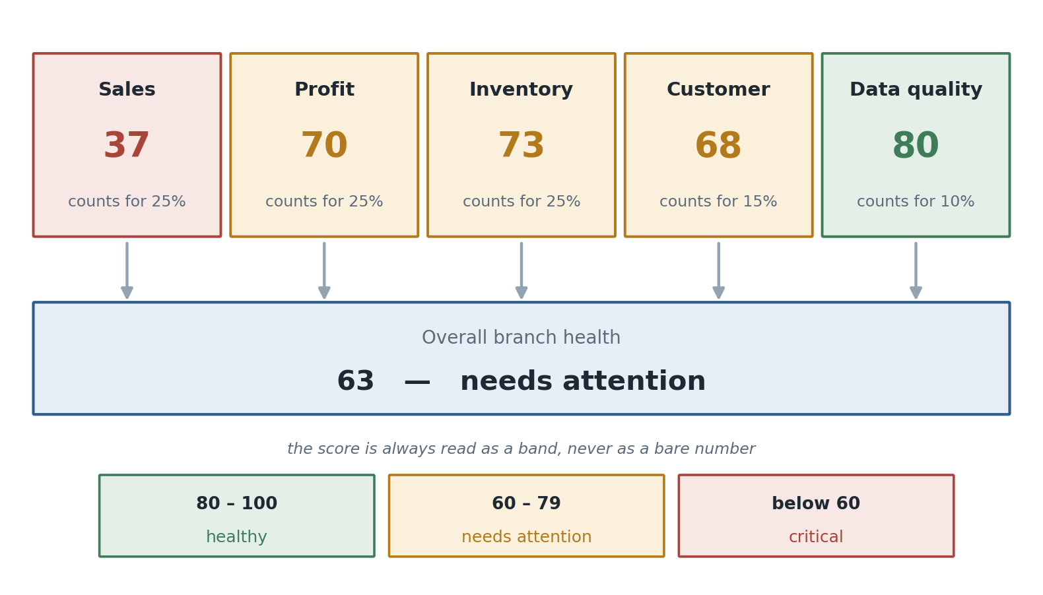
- Sales 25%, Profit 25%, Inventory 25%, Customer 15%, Data quality 10%.
- The app scores its own data too — a score built on bad records is worse than none.
- No growth scores 70, not 100 — flat is acceptable, not excellent.
- Anything that cannot be measured is left blank, never scored 0.

What the app watches for
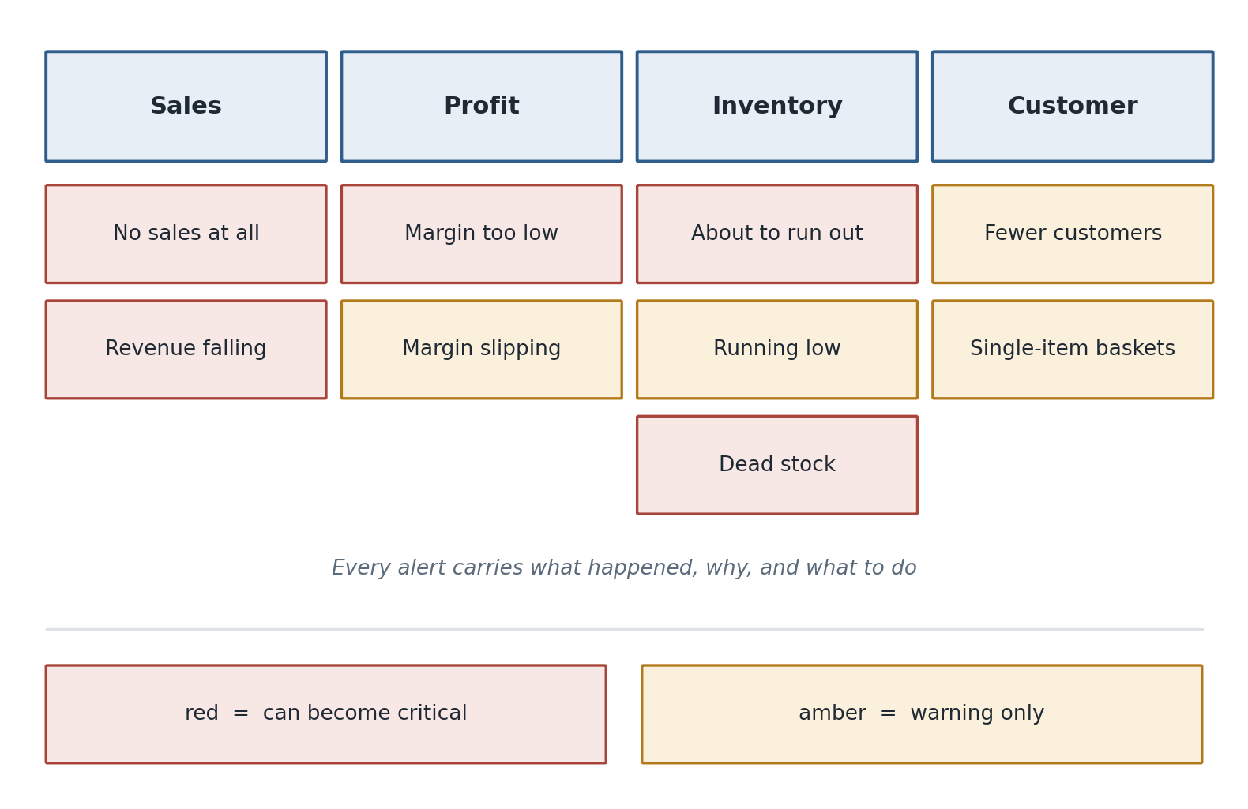
- One rule, one subject. Low margin and slipping margin are one conversation — only the worse one shows.
- No sales at all = a missing file, not a collapsed branch.
- Only two levels: critical and warning. A list where everything matters is a list nobody reads.

Every alert says what to do
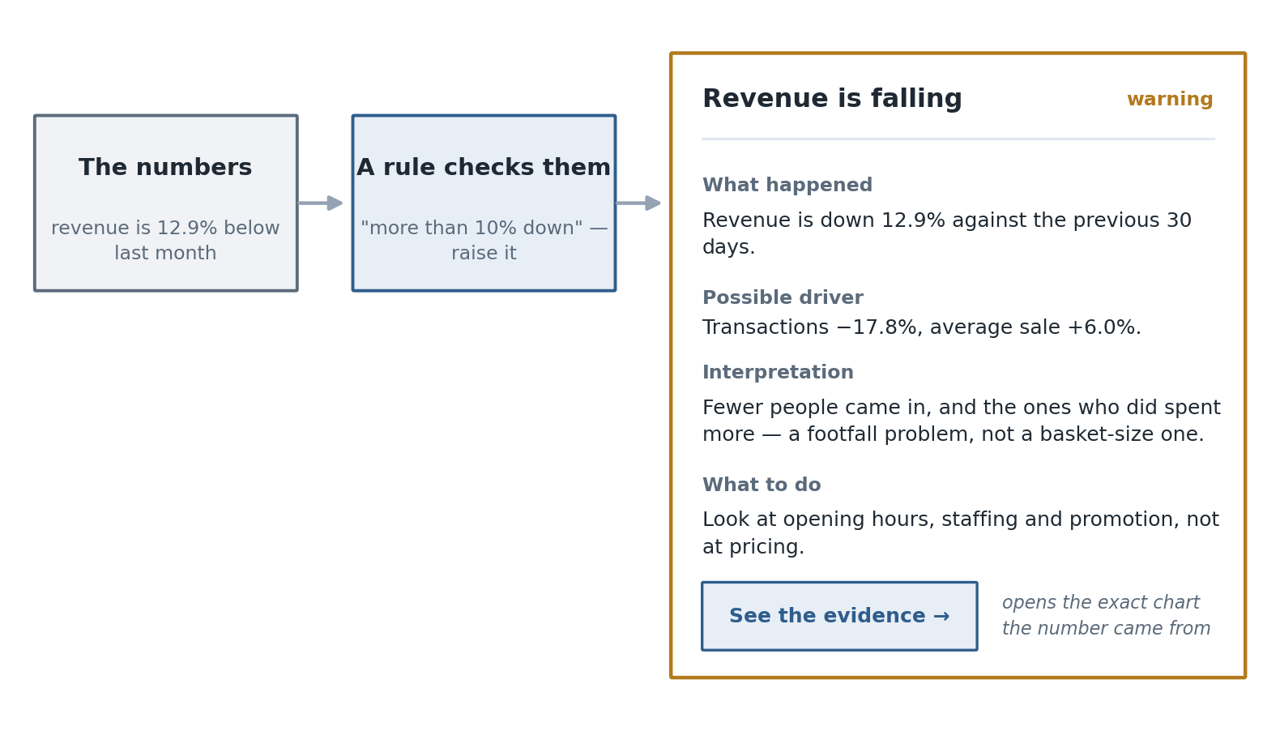
- Four parts: what happened, why, what it means, what to do.
- Every sentence is filled with measured figures — no AI writes them.
- The button opens the exact page the numbers came from.

Why it happened — measured, not guessed
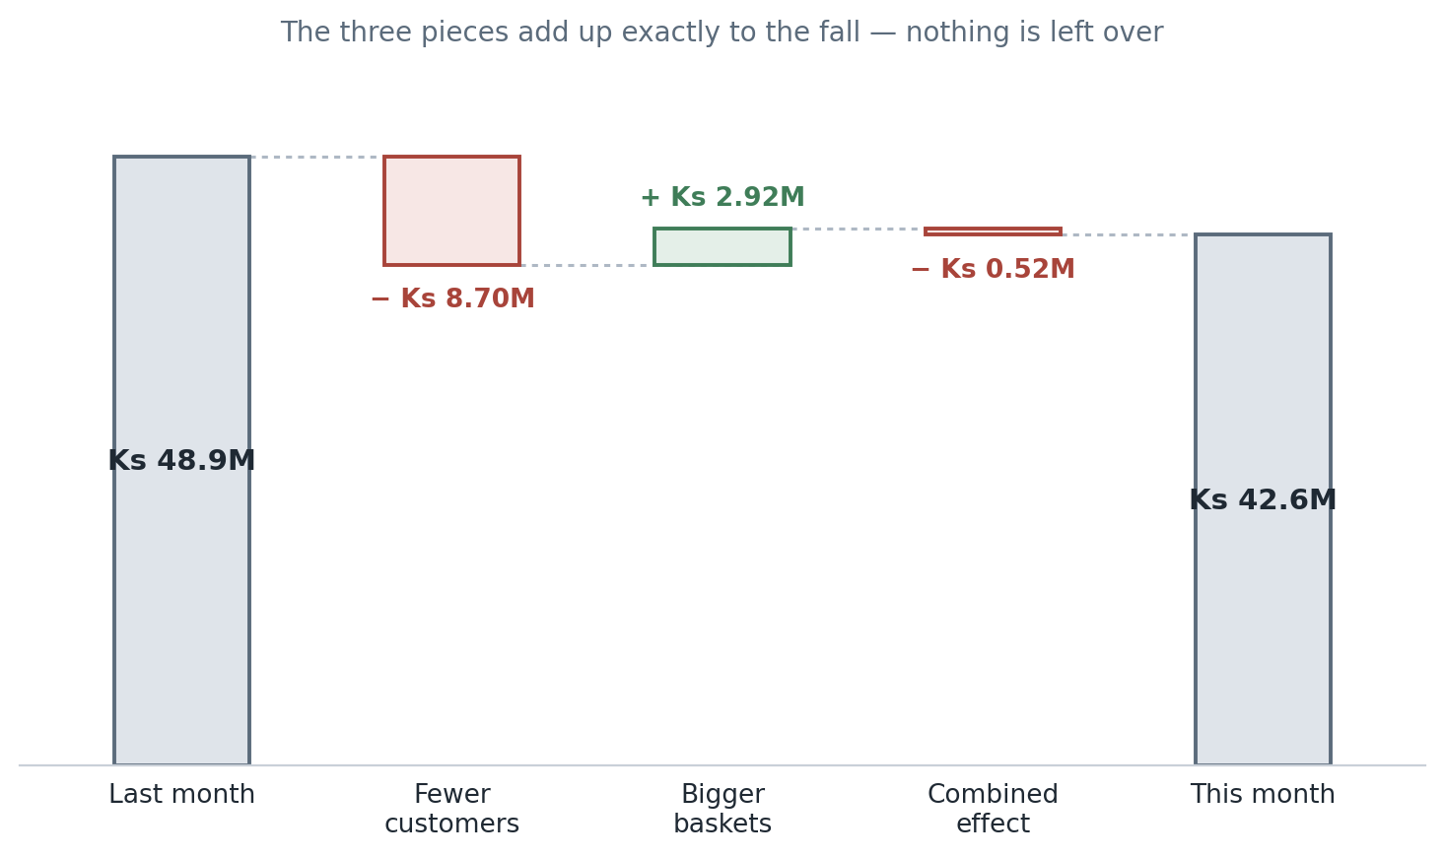
- Revenue = customers × average basket. So a fall splits into three exact pieces.
- The pieces add back up with nothing left over — so the biggest one is the cause.
- Fewer customers needs marketing. Smaller baskets needs pricing. Different decisions.

Is the data itself right?
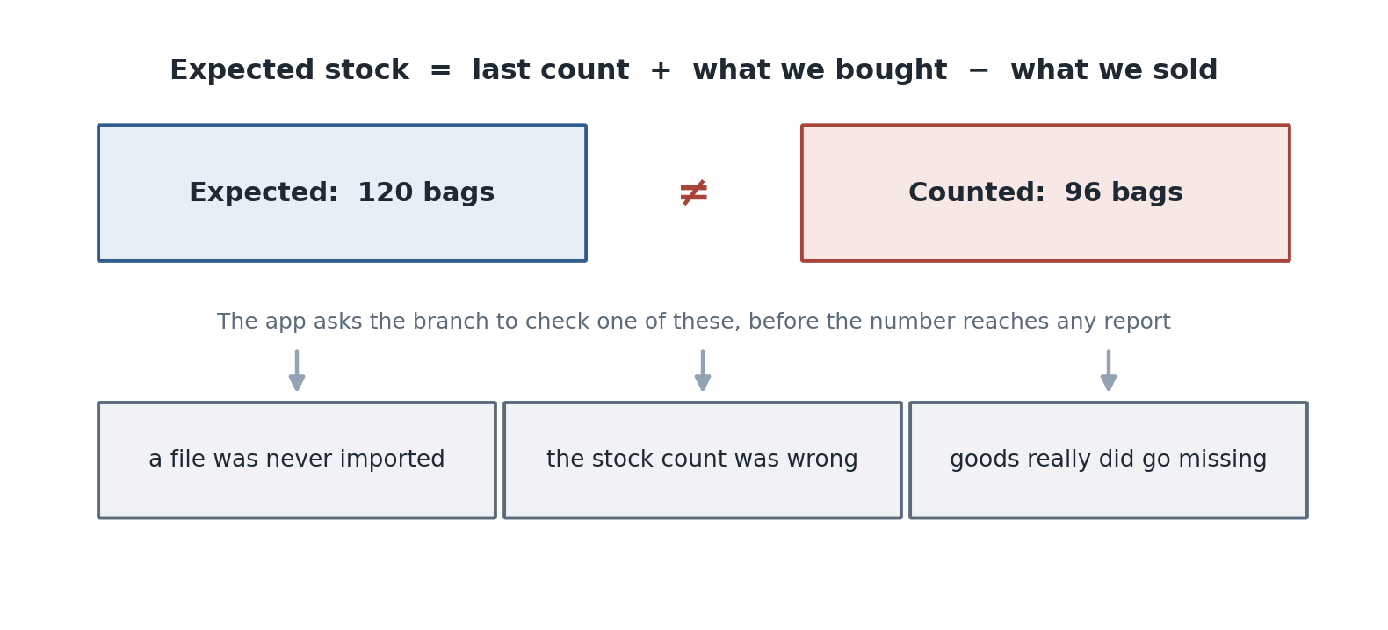
- The Warning page checks the records, not the business.
- It also catches impossible prices, zero quantities and products with no stock record.
- The fix loop: revert that import, correct the file, import again.

One branch, one month
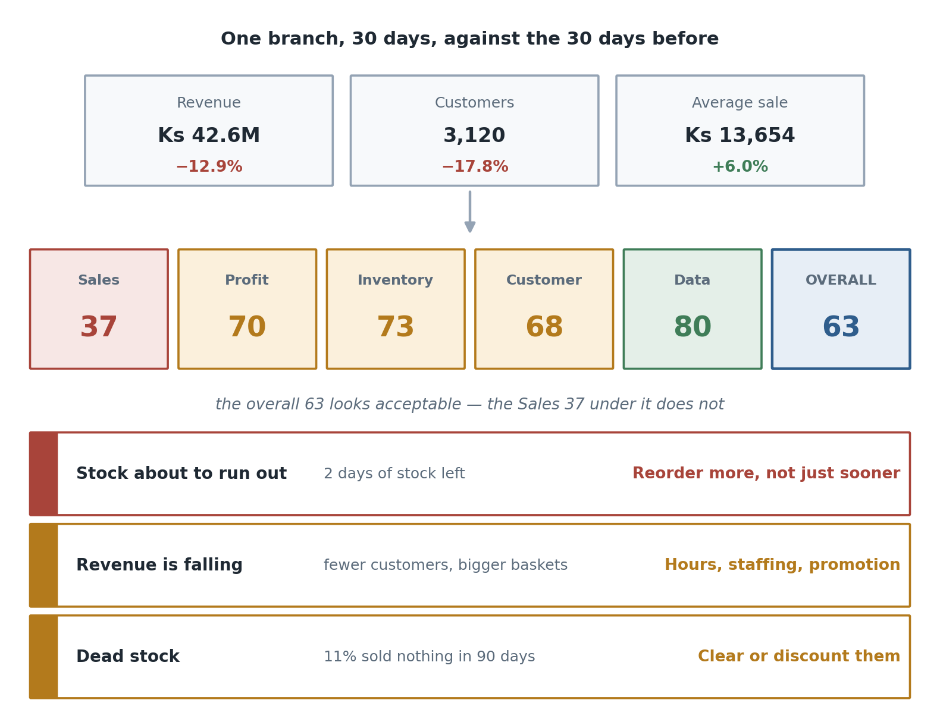
- A single overall score would have hidden the Sales 37. That is why five are always shown.
- Each alert links to the page holding its evidence.

Why it is built this way
- Computed, not generated. Templates filled with measured figures.
- Every number can be opened. Score → measures → figures → evidence.
- The business sets the thresholds. Weights and limits are settings.
- Unmeasured is never zero. It drops out and says what is missing.
- Data quality is part of the score, not a side page.

Likely questions
Question | Short answer
Isn't this just a dashboard? | A dashboard shows numbers. This scores them, names the problem, and says what to do.
Where do the weights come from? | They are settings the business can change, not fixed rules.
Is any of it AI-generated? | No. Every sentence is a template filled with measured figures.
What if data is missing? | That measure is left blank and says why. It is never scored 0.
Why is Warning separate? | One is the business going wrong, the other is the records being wrong.
Why no wholesale branch here? | Wholesale has no POS data — orders are entered by hand. Expected, not a gap.

